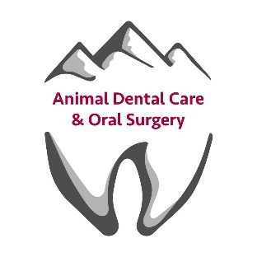
Montana Pet Dentistry & Oral Surgery Course Itinerary

We look forward to providing you with an excellent educational
experience, and would like to offer a few suggestions to enhance your
participation.

Schedule:
- Plan to arrive at 7:30 a.m. for a light continental breakfast and orientation.
- If you are traveling here on the morning of the class, please allow extra time for heavy traffic or unexpected problems.
- Lecture will begin promptly at 8:00 a.m.
- Several breaks between lectures are taken.
- Lunch is provided for all attendees. Vegetarian options will be available if requested ahead of time.
- Lab session will begin at 1pm.
- You can expect your day to end at approximately 5:00 p.m.

What to wear/bring:
• Comfortable clothes, casual dress is fine!
** When picking your outfit for the day, be aware that you will be working with cadaver heads

For Doctors scheduled for Level 2:
- Please bring some type of eye protection for use while operating the high-speed handpieces.
- Scrubs are a good choice for clothing, since you will be working on cadaver specimens.
- If available, bring some type of surgical magnification.
- For purchase of Surgical magnification, we recommend:
- http://www.surgitel.com/dental

