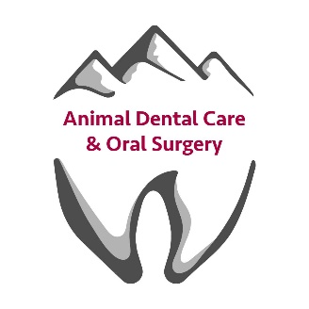
Your Stay in Bozeman, Montana

Our Address: 145 Mill Town Loop Unit C, Bozeman, MT 59718

Lodging Recommendations:
Country Inn & Suites by Radisson
5997 E Valley Center Rd, Bozeman, MT 59715

C'mon Inn
6139 E Valley Center Rd, Bozeman, MT 59718

Holiday Inn Express & Suites Belgrade, an IHG Hotel
309 W Madison Ave, Belgrade, MT 59714

Driving Directions:
From Country Inn & Suites by Radisson

• Head west toward E Valley Center Rd
• Turn right toward E Valley Center Rd
• Turn right onto E Valley Center Rd
• Turn left onto MT-85 S
• Turn right onto Ice Center Lane
• Turn right onto Avalanche Dr
• Turn right onto Mill Town Loop

From C'mon Inn

• Head north on E Valley Center Rd toward Catamount St
• Turn left onto MT-85 S
• Turn right onto Ice Center Lane
• Turn right onto Avalanche Dr
• Turn right onto Mill Town Loop

From Holiday Inn Express & Suites Belgrade, an IHG Hotel

• Head east on W Madison Ave
• Turn right onto Jackrabbit Ln
• Turn right onto Ice Center Lane
• Turn right onto Avalanche Dr
• Turn right onto Mill Town Loop

Restaurants in the Area:
Mr. Burrito’s – Authentic Mexican, Breakfast
Korner Klub – Bar food
Buffalo Bump – Pizza
Old Chicago – American
Country Corner Café – Breakfast
The Nova Cafe – Breakfast
The Western Café – Breakfast
Main Street Overeasy – Breakfast
The Mint – Fine Dining
The Local – American Saloon
Mackenzie River – Pizza

